**DATA COMMUNICATION & NETWORKING LAB**

***CEL 222***

lab 1



MALIK ZOHAIB MUSTAFA

01-134192-030

BSCS -4B

**Department of Computer Sciences**

**BAHRIA UNIVERSITY, ISLAMABAD**

**Q1: Basic cable construction and testing**

1. Straight
2. cross-over
3. Roll-over)

# Ans:

**Pictures Taken from Google**

The TIA/EIA standards - set of standards created by Telecommunications Industry Association (TIA) Electronic Industries (EIA)

*T568A*- (from left to right) white green, green, white orange, blue, white blue, orange, white brown then brown

*T568B*- (from left to right) white orange, orange, white green, blue, white blue, green, white brown and then brown

T568A and T568B:

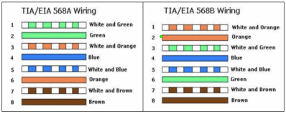

1. **Straight through**   - My simple analogy for this type of cable construction is that the COLOR CODING of the wires should match on BOTH END. (T568A to T568A) or (T568B to T568B) **Explained Above**.  
 -This type of cable implementation is used for connecting "different devices" such as Host to client i.e.  PC to Switch, Switch to Router.

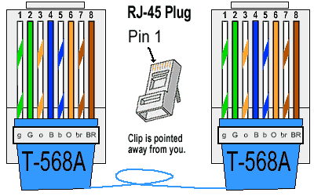 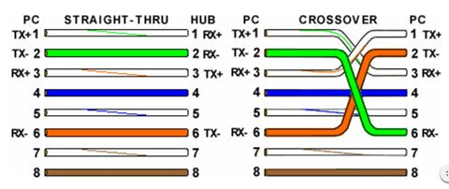

2. **Cross-Over**  - The Color coding of this type of cable is not the same on both ends, because they use (T568A to T568B)

-This Type of cable implementation is used for connecting *"same devices"*such as*host to host i.e., PC to PC, Switch to Switch.*

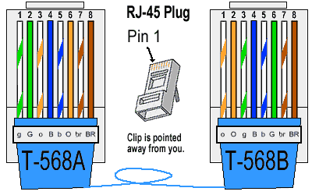 

3. **Roll-Over** - The Color coding for this type of cable construction is the reverse of the other end of the cable. (T568A to T568A in reverse color) or (T568B to T568B in reverse color).

 - This type of cable implementation is used for connecting on *"console port"* such as *Router through Console , Switch through Console port*

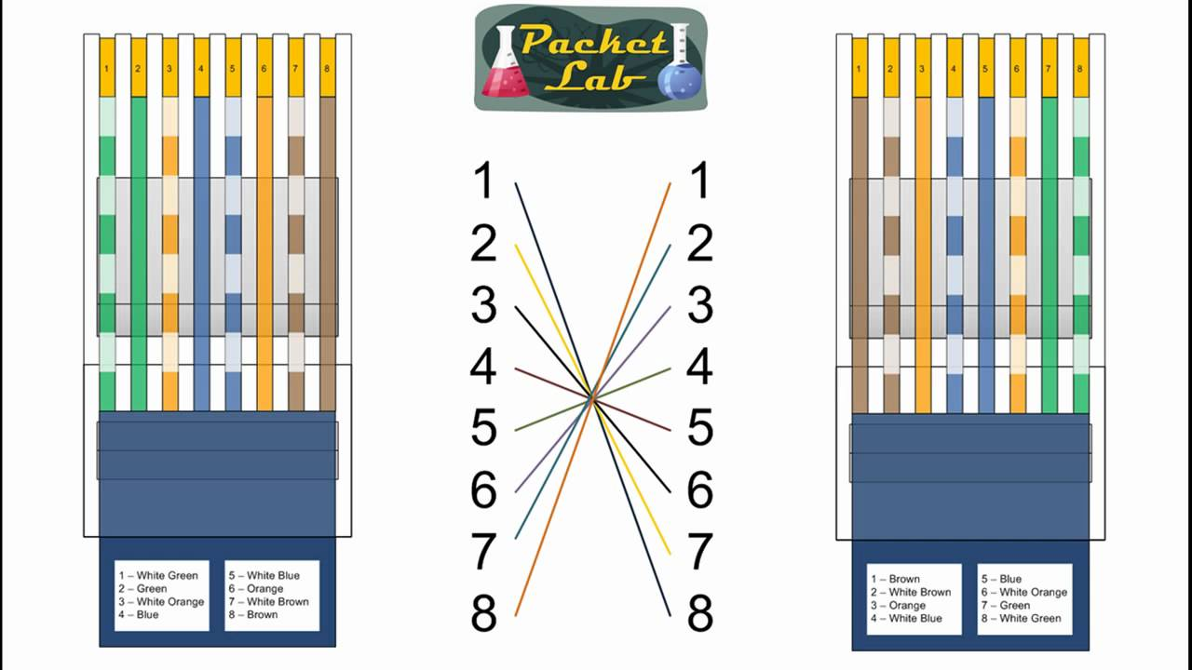

**Construction:**

A Category 5e cable meets the requirements for transmitting data on an IEEE 802.3 computer network at speeds of 100 Mbps or less. According to specifications published by the Telecommunications Industry Association (TIA) these cables may vary in length from a minimum of about 3 feet to a maximum of 100meters (about 328 feet).

**Tools and Materials Required**

The following is a list of tools and materials that are needed to build a short

Category 5e (CAT 5e) network cable.

* One 6-foot section of CAT 5 unshielded twisted pair (UTP) cable

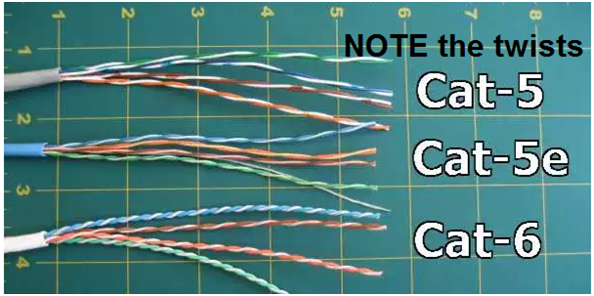

* Two RJ 45 connectors

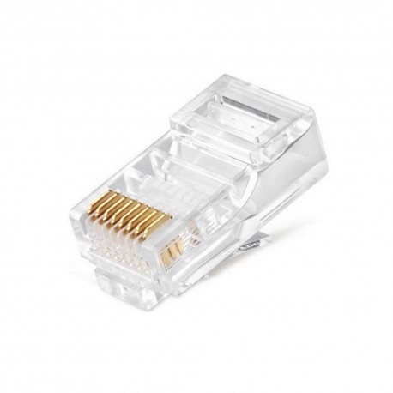

* One wire stripping tool

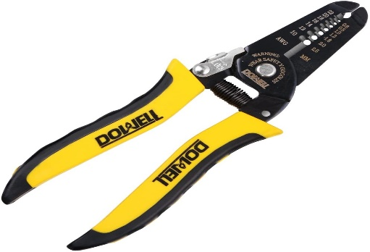

* One cable-end crimping tool

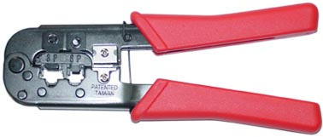

* One cable tester

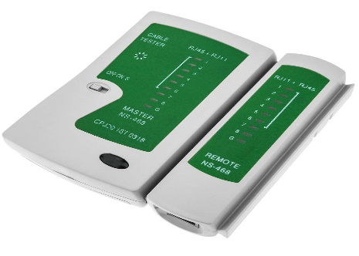

**Procedure:**

|  |
| --- |
| 1. **Carefully remove the outer jacket of the cable.** Be careful when stripping the jacket as to not nick or cut the internal wiring. One good way to do this is to cut lengthwise with wire stripping tool along the side of the cable, away from yourself, about an inch toward the open end. 2. **Inspect the newly revealed wires for any cuts or scrapes that expose the copper wire inside.** If you have breached the protective sheath of any wire, you will need to cut the entire segment of wires off and start over at step one. Exposed copper wire will lead to crosstalk, poor performance or no connectivity at all. It is important that the jacket for all network cables remains intact. 3. **Untwist the pairs so they will lay flat between your fingers.** The white piece of thread or plastic can be cut off. For easier handling, cut the wires so that they are 3/4" (19 mm) long from the base of the jacket and even in length. 4. **Arrange the wires based on the wiring specifications you want as discussed above.** 5. **Press all the wires flat and parallel between your thumb and forefinger.** 6. **Keep the wires flat and in order as you push them into the RJ-45 plug with the flat surface of the plug on top.**  Verify that the sequence is still correct before crimping. 7. **Place the wired plug into the crimping tool.** Give the handle a firm squeeze. Once the crimp is completed, the handle will reset to the open position. To ensure all pins are set, some prefer to double-crimp by repeating this step. 8. **Repeat all the above steps with the other end of the cable.** The way you wire the other end (568A or 568B) will depend on whether you are making a straight-through, rollover, or cross-over cable 9. **Test the cable using cable tester to ensure that it will function in the field.** |

**Testing Procedure:**

|  |
| --- |
| * Select the cable to be tested and make sure it is not plugged to any electrical power and free of any packaging or tangled with other cables, to prevent false reading. * Visually inspect the cable for damage. If cable is broken or torn it should be replaced. * Plug the network cable into the appropriate port on the cable tester, and then connect the other end of the cable to the remote. * Switch the tester on to test your cable. The tester will show results, and if applicable, will indicate what the potential problem is. |